

**Title: PawCore Systems Hands-On Lab — From Signals to Decisions with Snowflake Intelligence (90 minutes)**

**Duration**

Total: 90 minutes (hands-on 75–80 minutes, Q&A 10–15 minutes)

**Audience**

Data/AI practitioners, analytics engineers, sales engineers, Snowflake builders

**Objectives**

Tell a cohesive PawCore story: solve "The Mystery of the Missing Revenue" by unifying structured and unstructured data to diagnose regional under-performance, uncover product issues, assess campaign ROI, and automate executive updates with a Snowflake Intelligent Agent.

**Story Setup (What happened?)**

Q4 revenue beat targets overall by 15%, but EMEA region underperformed by 23% for SmartCollar specifically. Leadership is baffled because:

- Marketing spent 40% more on "Holiday Fit for Pets" campaign in EMEA

- Customer satisfaction scores dropped 15% in EMEA during Q4

- Support tickets increased 200% for battery-related issues

- No one can connect the dots between these signals

Our mission: Investigate across structured and unstructured data to solve this mystery, find the root cause, and provide an actionable solution to prevent future revenue losses.

**Assets You Will Use**

**Structured**: pawcore_sales.csv, pet_owners.csv, device_sales_by_region.csv, fitbit_inventory.csv, vet_feedback.csv, email_campaigns.csv, enhanced_sales_data.csv, social_media_posts.csv

**Unstructured**: Q4_2024_PawCore_Financial_Report.md (quarterly dashboard), Sales_Performance_Q4_2024.md (sales report), PawCore Quarterly Call.mp3 (quarterly call), Quarterly_Sales_Speech_PawCore.md (call transcript), pawcore_slack.csv (Slack), customer_reviews.csv (reviews), SmartCollar Product Photo.jpeg (product image), Customer Journey Infographic.pdf (infographic)

**Snowflake**: Role SNOWFLAKE_INTELLIGENCE_ADMIN_RL, Warehouse PAWCORE_INTELLIGENCE_WH, Database PAWCORE_INTELLIGENCE_DEMO with schemas BUSINESS_DATA, DOCUMENTS, AGENTS

**Agenda and Timeboxes**

0–5 min: Story and goals

5–20 min: Environment and data loading

20–35 min: Semantic Views + Cortex Analyst

35–50 min: Document AI (PDFs/images) + Slack + Reviews

50–60 min: Cortex Search Services over unstructured content

60–70 min: Quarterly call insights and cross-signal sentiment

70–80 min: Build the Intelligent Agent and email yourself

80–90 min: Q&A

**Section 1 (0–5 min): Introduce the Story and Target Outcome**

Frame the business questions:

- What caused the 23% SmartCollar revenue shortfall in EMEA?

- Are battery issues mentioned in customer feedback and support data?

- Did the "Holiday Fit for Pets" campaign contribute to or mask the problem?

- Can we automate this type of investigation for future issues?

Outcome: A root-cause narrative and an automated email summary to leadership.

***[SCREENSHOT: Opening slide or document title with objectives]***

**Section 2 (5–20 min): Environment Setup and Data Loading**

**1) Use role, warehouse, and create database/schemas**

USE ROLE ACCOUNTADMIN;

CREATE OR REPLACE WAREHOUSE PAWCORE_INTELLIGENCE_WH WAREHOUSE_SIZE = 'XSMALL' AUTO_SUSPEND = 60 AUTO_RESUME = TRUE;

CREATE OR REPLACE DATABASE PAWCORE_INTELLIGENCE_DEMO;

CREATE OR REPLACE SCHEMA PAWCORE_INTELLIGENCE_DEMO.BUSINESS_DATA;

CREATE OR REPLACE SCHEMA PAWCORE_INTELLIGENCE_DEMO.DOCUMENTS;

CREATE OR REPLACE SCHEMA PAWCORE_INTELLIGENCE_DEMO.AGENTS;

USE DATABASE PAWCORE_INTELLIGENCE_DEMO;

USE SCHEMA BUSINESS_DATA;

USE WAREHOUSE PAWCORE_INTELLIGENCE_WH;

**2) Create file formats and stages**

CREATE OR REPLACE FILE FORMAT CSV_FORMAT TYPE = CSV FIELD_OPTIONALLY_ENCLOSED_BY='"' SKIP_HEADER = 1;

CREATE OR REPLACE FILE FORMAT BINARY_FORMAT TYPE = BINARY;

CREATE OR REPLACE STAGE INTERNAL_DATA_STAGE FILE_FORMAT = CSV_FORMAT;

CREATE OR REPLACE STAGE DOCUMENT_STAGE;

CREATE OR REPLACE STAGE IMAGE_STAGE FILE_FORMAT = BINARY_FORMAT;

CREATE OR REPLACE STAGE AUDIO_STAGE FILE_FORMAT = BINARY_FORMAT;

**3) Upload files to stages (UI: Databases → Stages → Upload)**

- Upload device_sales_by_region.csv, email_campaigns.csv, enhanced_sales_data.csv, fitbit_inventory.csv, pawcore_sales.csv, pet_owners.csv, social_media_posts.csv, vet_feedback.csv to **INTERNAL_DATA_STAGE**.

- Upload Q4_2024_PawCore_Financial_Report.md, Sales_Performance_Q4_2024.md, Quarterly_Sales_Speech_PawCore.md, pawcore_slack.csv, customer_reviews.csv to **DOCUMENT_STAGE**:

- Upload SmartCollar Product Photo.jpeg, Customer Journey Infographic.pdf to **IMAGE_STAGE**.

- Upload PawCore Quarterly Call.mp3 to **AUDIO_STAGE**.

You can find an organized folder with all Data [here](https://drive.google.com/uc?export=download&id=169wCi9GBsEm81Gx48Sj4t-iAN4fZumAU)

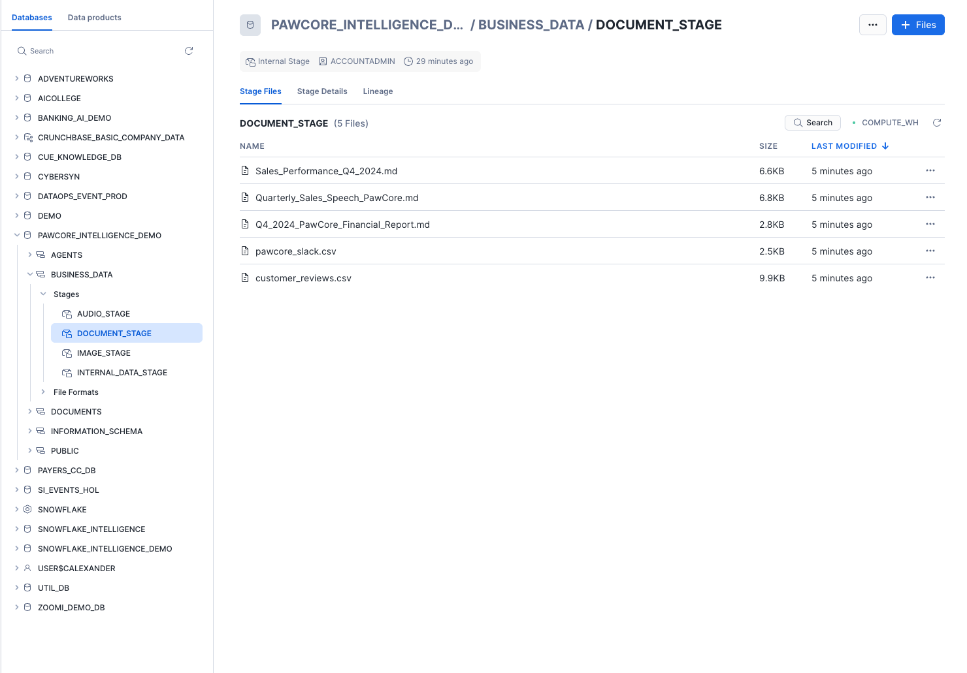

**4) Create core tables and load structured data**

Create tables based on your CSV files:

PAWCORE_SALES (from pawcore_sales.csv)

PET_OWNERS (from pet_owners.csv)

DEVICE_SALES_BY_REGION (from device_sales_by_region.csv)

FITBIT_INVENTORY (from fitbit_inventory.csv)

VET_FEEDBACK (from vet_feedback.csv)

EMAIL_CAMPAIGNS (from email_campaigns.csv)

ENHANCED_SALES_DATA (from enhanced_sales_data.csv)

SOCIAL_MEDIA_POSTS (from social_media_posts.csv)

**Load** with COPY INTO from @INTERNAL_DATA_STAGE.

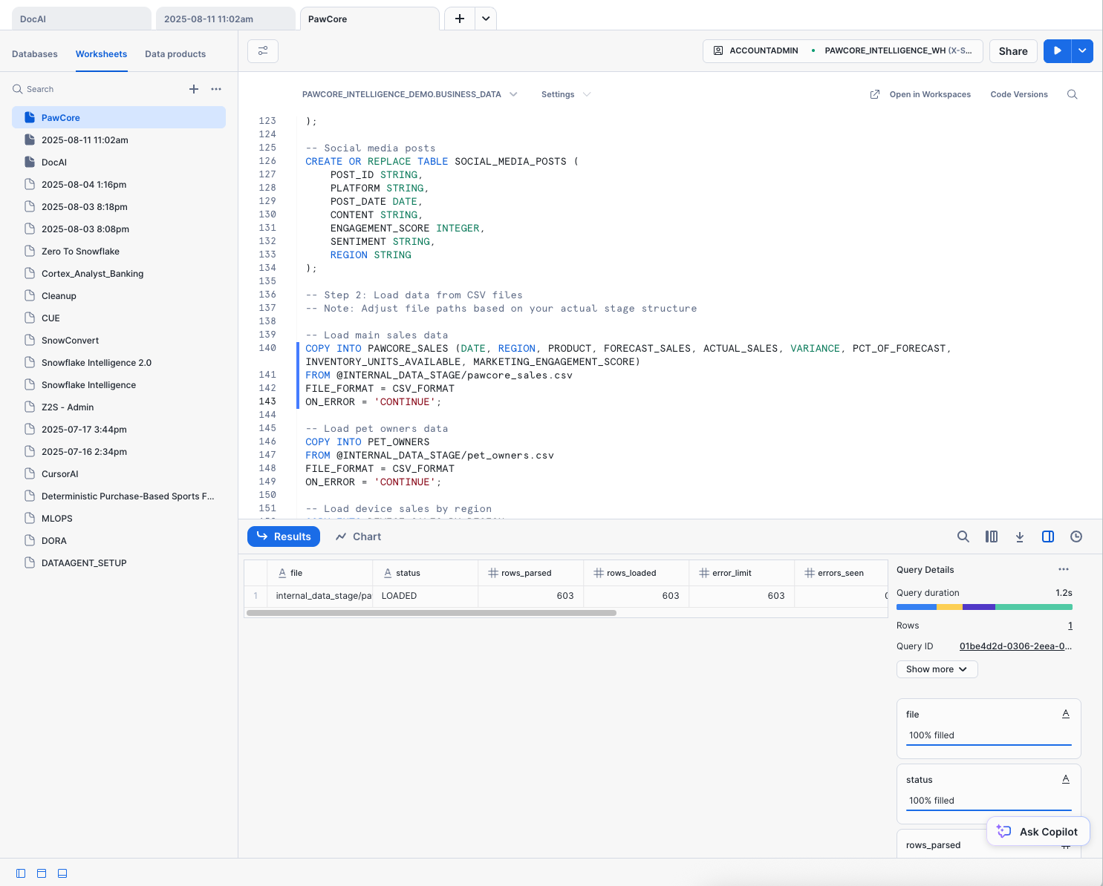

***[SCREENSHOT: Worksheet showing successful COPY row counts]***

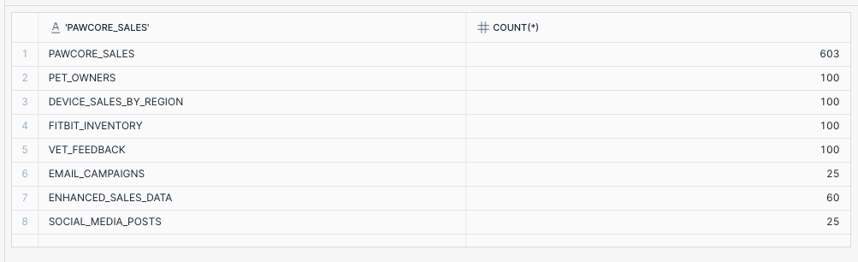

**Section 3 (20–35 min): Semantic Views and Cortex Analyst (Structured Analysis)**

#### 

#### **Navigate to Cortex Analyst**

1. In Snowflake Snowsight, switch to your PAWCORE_DEMO_ROLE role.
2. In the left sidebar, expand **AI & ML** and click **Studio**.
3. Select **Cortex Analyst**.
4. Select **Create New Semantic View** option. 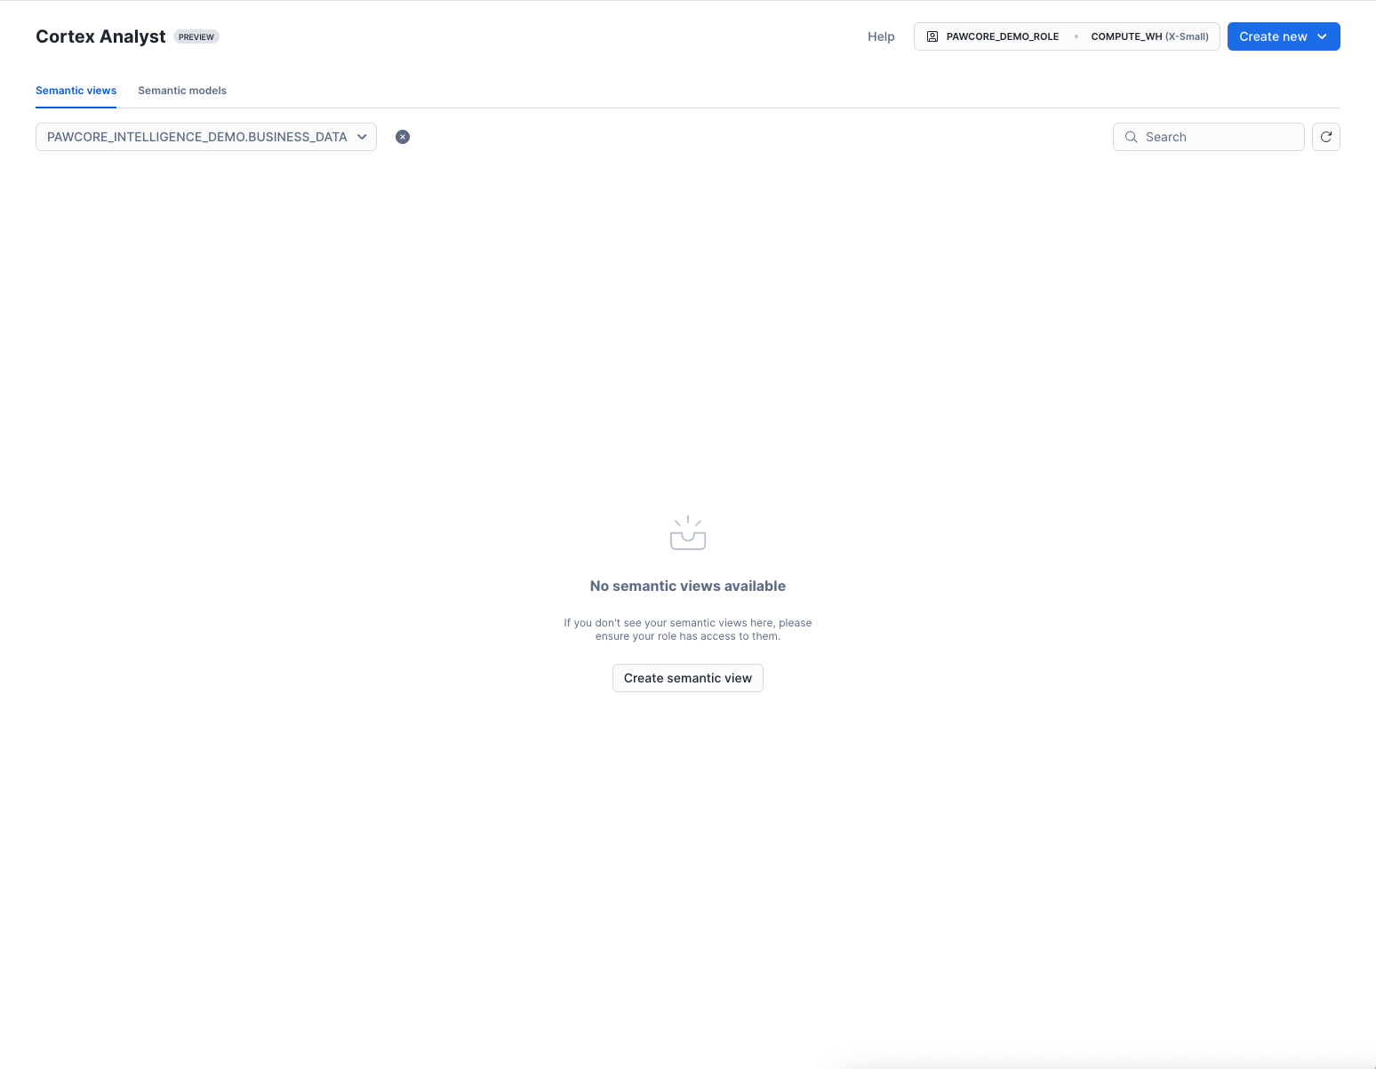

**1) Create Sales Semantic View (**SQL as backup**)**

**Location to store:** PAWCORE_INTELLIGENCE_DEMO.BUSINESS_DATA

**Name**: PAWCORE_SALES_SEMANTIC_VIEW

**Description**:

*PawCore sales and growth performance across regions and products, including forecast vs actual, variance, inventory, marketing campaigns, customer segments, social media engagement, and supporting device and vet feedback signals. Use this view to analyze revenue trends, regional/product performance, campaign impact, and operational drivers of sales outcomes from 2018–2025.*

**Tables**:

1. PAWCORE_SALES (primary key),
2. PET_OWNERS,
3. DEVICE_SALES_BY_REGION,
4. FITBIT_INVENTORY,
5. VET_FEEDBACK,
6. EMAIL_CAMPAIGNS,
7. ENHANCED_SALES_DATA,
8. SOCIAL_MEDIA_POSTS

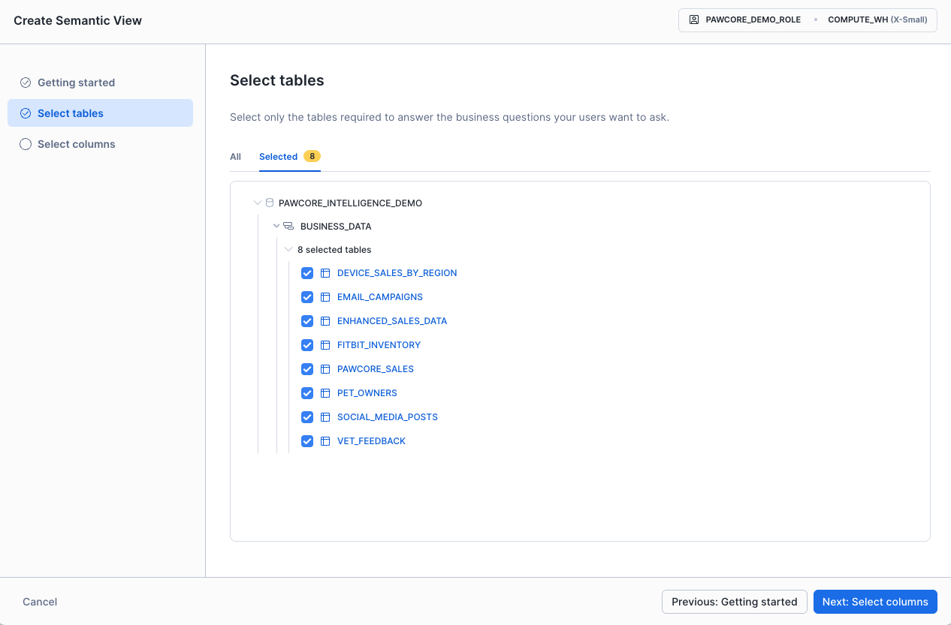

Select columns:

**PAWCORE_SALES** (Select All)

Columns: DATE, REGION, PRODUCT, ACTUAL_SALES, FORECAST_SALES, VARIANCE, PCT_OF_FORECAST, INVENTORY_UNITS_AVAILABLE, MARKETING_ENGAGEMENT_SCORE

**PET_OWNERS**

Columns: CUSTOMER_ID, CUSTOMER_NAME, REGION, SEGMENT, JOIN_DATE

*Exclude: PET_TYPE, PET_NAME*

**DEVICE_SALES_BY_REGION** (Select All)

Columns: DATE, REGION, DEVICE_TYPE, UNITS_SOLD, REVENUE, GROWTH_RATE

**FITBIT_INVENTORY** (Select All)

Columns: PRODUCT_ID, PRODUCT_NAME, REGION, INVENTORY_LEVEL, REORDER_POINT, LAST_RESTOCK_DATE

**VET_FEEDBACK**

Columns: FEEDBACK_ID, VET_NAME, PRODUCT, RATING, DATE, REGION

Exclude: FEEDBACK_TEXT

**EMAIL_CAMPAIGNS** (Select All)

Columns: CAMPAIGN_ID, CAMPAIGN_NAME, START_DATE, END_DATE, REGION, BUDGET, SPEND, CLICKS, CONVERSIONS

**ENHANCED_SALES_DATA** (Select All)

Columns: SALE_ID, DATE, REGION, PRODUCT, CUSTOMER_SEGMENT, SALES_AMOUNT, DISCOUNT_AMOUNT, NET_SALES

**SOCIAL_MEDIA_POSTS**

Columns: POST_ID, PLATFORM, POST_DATE, ENGAGEMENT_SCORE, SENTIMENT, REGION

Exclude: CONTENT

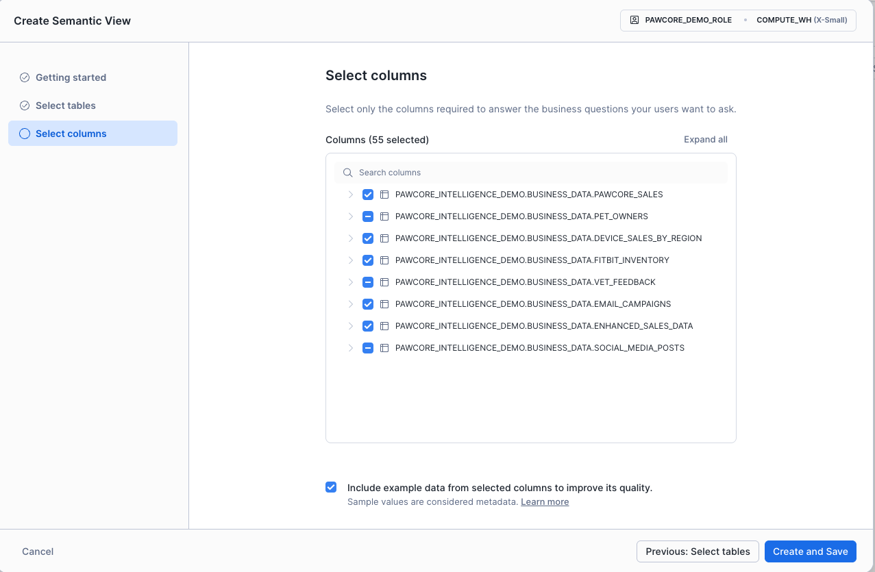

Note: You can keep the *“Include example data from selected columns to improve its quality”* checked. It helps the model understand typical values (e.g., regions, products, device types) and improves NLQ quality. We’re not exposing long free‑text or sensitive fields, so it’s safe.

[Add synonyms, descriptions, and relationships as appropriate.](?tab=t.f79q6ijx5d0f)

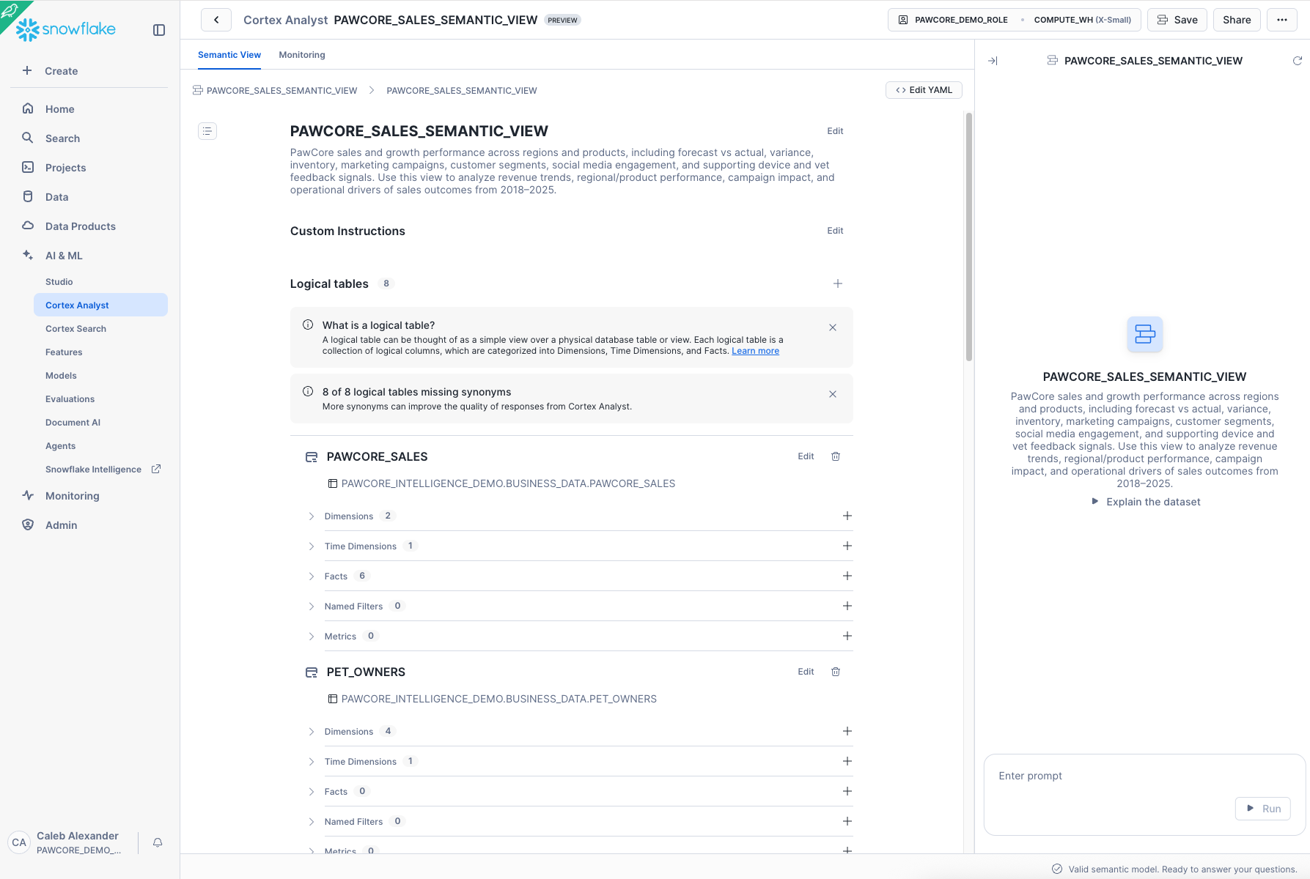

**Ask questions in natural language (Cortex Analyst UI)**

Show Q4 2024 sales by region and product with forecast vs actual and variance. Include a grouped bar chart.

Which regions under-performed forecast for SmartCollar and by how much?

What inventory or engagement factors correlate with the variance?

**2) Create Cortex Analyst Service**

Name: Analyst_PawCore_Sales_Performance

Semantic View: PAWCORE_SALES_SEMANTIC_VIEW

Warehouse: PAWCORE_INTELLIGENCE_WH

***[SCREENSHOT: Analyst service creation confirmation]***

**3) Ask questions in natural language (Cortex Analyst UI)**

“Show Q4 2024 sales by region and product with forecast vs actual and variance. Include a grouped bar chart.”

“Which regions under-performed forecast for SmartCollar and by how much?”

“What inventory or engagement factors correlate with the variance?”

***[SCREENSHOT: Analyst result table and chart]***

Insight checkpoint: Note the variance for SmartCollar in EMEA and any engagement/inventory signals.

**Section 4 (35–50 min): Document AI + Slack + Reviews (Unstructured Cues)**

**1) Process PDFs and images with Document AI (UI)**

Project A: "PawCore Analyst Reports" → ingest Q4_2024_PawCore_Financial_Report.md and Sales_Performance_Q4_2024.md; extract text, tables, KPIs.

Project B: "PawCore Infographics" → ingest SmartCollar Product Photo.jpeg and Customer Journey Infographic.pdf; extract numeric metrics and captions.

***[SCREENSHOT: Document AI extraction previews and fields]***

**2) Materialize parsed content for search and queries (DOCUMENTS schema)**

Create or use a table DOCUMENTS.PARSED_CONTENT with columns: relative_path, file_url (or presigned URL), title, content (extracted text).

Load Slack CSV into DOCUMENTS.SLACK_MESSAGES (columns such as channel, timestamp, message_text, author).

Load customer reviews CSV into DOCUMENTS.CUSTOMER_REVIEWS (rating, product, review_text, date).

***[SCREENSHOT: Sample rows from PARSED_CONTENT, SLACK_MESSAGES, CUSTOMER_REVIEWS]***

**3) Quick checks**

SELECT COUNT(*) from each table; spot check content for SmartCollar battery mentions and campaign results.

***[SCREENSHOT: Counts and a sample SELECT with highlighted text]***

**Section 5 (50–60 min): Cortex Search Services (Following the Evidence Trail)**

**1) Create focused search services**

Search_PawCore_Finance_Docs on DOCUMENTS.PARSED_CONTENT filtered to finance/review documents.

Search_PawCore_Product_Docs on DOCUMENTS.PARSED_CONTENT filtered to SmartCollar/product topics.

Search_PawCore_Operations_Docs union of PARSED_CONTENT + SLACK_MESSAGES + CUSTOMER_REVIEWS for broad ops sentiment.

***[SCREENSHOT: SHOW CORTEX SEARCH SERVICES and a sample search query in UI]***

**2) Ask targeted questions**

"Summarize key Q4 drivers and risks mentioned in the quarterly review."

"Find all mentions of battery performance issues for SmartCollar across documents, Slack, and reviews."

"Are there references to returns/refunds related to SmartCollar?"

***[SCREENSHOT: Search result snippets highlighting relevant passages]***

**Section 6 (60–70 min): Quarterly Call Insights and Cross-Signal Sentiment (Connecting the Dots)**

1) Load the quarterly call transcript into DOCUMENTS.CALL_TRANSCRIPT(TEXT) from Quarterly_Sales_Speech_PawCore.md.

2) Create a unified view for sentiment and mention counts

CUSTOMER_SIGNAL_FEED as union of Slack message_text, review_text, and call transcript text.

Compute average sentiment by source using SNOWFLAKE.CORTEX.SENTIMENT.

***[SCREENSHOT: Sentiment by source results and a simple bar chart (Worksheet or Streamlit)]***

Investigation checkpoint: Look for correlation between EMEA variance and SmartCollar battery sentiment trend. Note if campaign references appear positive or neutral.

**Section 7 (70–80 min): Build the Intelligent Agent and Solve the Mystery**

**1) Email integration and procedure (AGENTS schema)**

Create NOTIFICATION INTEGRATION PAWCORE_EMAIL_INT (TYPE = EMAIL, ENABLED = TRUE).

Create procedure AGENTS.SEND_MAIL(recipient, subject, content) in Python that calls SYSTEM$SEND_EMAIL with HTML content.

***[SCREENSHOT: Procedure successfully created]***

**2) Create the Agent with tools**

Name: PAWCORE_BI_AGENT

Instructions: You are a revenue detective. Analyze structured data via Semantic Views; search unstructured content via Cortex Search; synthesize insights; create charts where useful; avoid citation markers; deliver concise executive summaries with recommendations. Focus on solving the EMEA SmartCollar revenue mystery.

Tools:

- cortex_analyst_text_to_sql → Analyst_PawCore_Sales_Performance

- cortex_search → Search_PawCore_Product_Docs, Search_PawCore_Finance_Docs, Search_PawCore_Operations_Docs

- procedure → AGENTS.SEND_MAIL

***[SCREENSHOT: Agent configuration summary showing tools enabled]***

**3) Run the end-to-end prompt**

"Solve the mystery of the missing EMEA SmartCollar revenue. Analyze performance by region in Q4 2024, correlate to customer sentiment and documented issues, and recommend top 3 actions. Include a chart comparing forecast vs actual by region. Then email the executive summary to me at caleb.alexander@snowflake.com."

***[SCREENSHOT: Agent response showing chart and a confirmation that email was sent]***

**4) Verify the email**

Check inbox for subject "PawCore Q4 Findings — SmartCollar Performance and Actions".

Confirm summary includes EMEA under-performance, battery theme evidence, campaign ROI outcome, and three prioritized actions (e.g., firmware update rollout, targeted EMEA support playbook, campaign optimization).

***[SCREENSHOT: Email in inbox (redacted)]***

**Section 8 (80–90 min): Q&A and Extensions**

Variations: add financial gross margin analysis; attribute campaign lift; product lifecycle trends; support ticket topics.

Troubleshooting:

- Services "INITIALIZING": wait and ensure PAWCORE_INTELLIGENCE_WH is running.

- No results: verify data loaded and search scopes; check permissions on schemas/stages.

- Charts missing: explicitly ask "include a bar chart," or visualize in Worksheet/Streamlit.

Appendix: Quick Reference (copy/paste)

Prompts to try

Analyst: "Quarter-over-quarter change in SmartCollar revenue and variance by region with a grouped bar chart."

Search: "Summarize all mentions of battery performance issues in 3 bullet points."

Agent: "Create a one-page executive briefing combining KPIs and customer voice and email it to me."

**Key objects**

Warehouse: PAWCORE_INTELLIGENCE_WH

Database/Schemas: PAWCORE_INTELLIGENCE_DEMO (BUSINESS_DATA, DOCUMENTS, AGENTS)

Semantic View: PAWCORE_SALES_SEMANTIC_VIEW

Analyst Service: Analyst_PawCore_Sales_Performance

Search Services: Search_PawCore_Finance_Docs, Search_PawCore_Product_Docs, Search_PawCore_Operations_Docs

Email Integration: PAWCORE_EMAIL_INT

Procedure: AGENTS.SEND_MAIL

Agent: PAWCORE_BI_AGENT

File names (replace with your exact paths)

**Structured**: pawcore_sales.csv, pet_owners.csv, device_sales_by_region.csv, fitbit_inventory.csv, vet_feedback.csv, email_campaigns.csv, enhanced_sales_data.csv, social_media_posts.csv

**Unstructured**: Q4_2024_PawCore_Financial_Report.md, Sales_Performance_Q4_2024.md, PawCore Quarterly Call.mp3, Quarterly_Sales_Speech_PawCore.md, pawcore_slack.csv, customer_reviews.csv, SmartCollar Product Photo.jpeg, Customer Journey Infographic.pdf

**Next Steps to Finalize**

Confirm your exact file names/paths if different from the samples above.

If the call MP3 has no transcript, decide whether to use a pre-transcribed text or skip that portion.